**Installing required packages:**

$ sudo apt -y install bridge-utils cpu-checker libvirt-clients libvirt-daemon qemu qemu-kvm

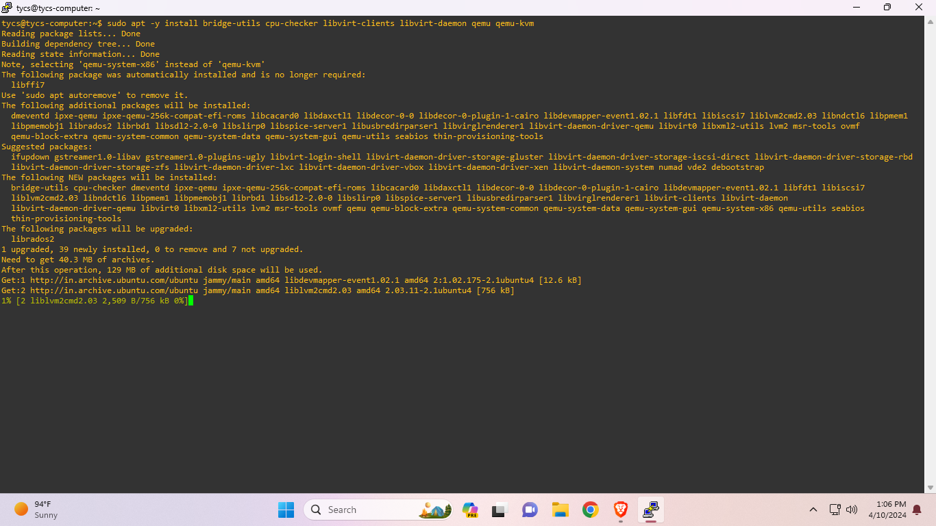

**Checking virtualization capabilities:**

$ kvm-ok

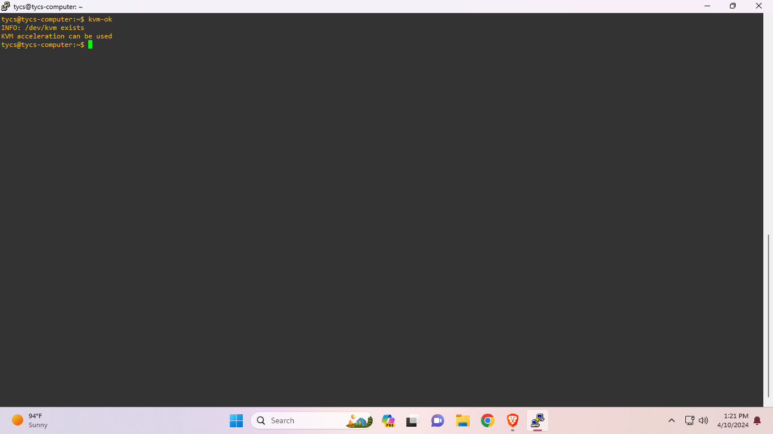

**Installing virt-manager package:**

$ sudo apt install virt-manager

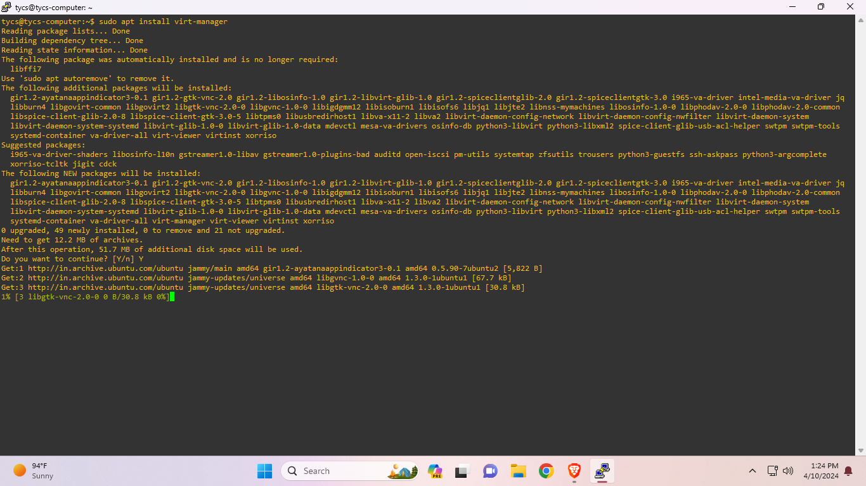

**Installing Ubuntu on VM:**

$ sudo virt-install --name ubuntu-guest --os-variant ubuntu20.04 --vcpus 2 --ram 2048 --location http://ftp.ubuntu.com/ubuntu/dists/focal/main/installer-amd64/ --network bridge=virbr0,model=virtio --graphics none --extra-args='console=ttyS0,115200n8 serial'

